MLPR Lab-14

This assignment is to classify the Indian currency notes by the use of Transfer Learning. RESNET50 pretrained model will be used for feature extraction through the deep network’s layers. Subsequently, SVM will be used for classification.

Think about it for a moment! How wonderful it is that a deep neural network trained on millions of images but which has never before seen any Indian currency note can still be used to extract meaningful features. Thus, in this way, Transfer Learning helps us to adapt such deep neural networks for our much smaller datasets. Otherwise, we would not be able to do classification so well on such small datasets (You can also try Transfer Learning by tuning a few layers of the RESNET50 model later for this or other problems as a take-home exercise)

**Instructions:**

* Due time: 1:30 PM
* Submit all the generated outputs.
* Many of you are not appearing in the lab and just uploaded the results without showing me. Sometimes there had some twist in parameters to get the correct output that you might have not gotten and uploaded the output simply you produced. Please be in the lab.
* There can be a difference in values in the confusion matrix as compared to the given output. Show me the outputs for the verification of the results.
* Approx. program execution time – 1-2 minutes

**Step 1:** Import libraries

* import os
* import numpy as np
* import matplotlib.pyplot as plt
* from sklearn.metrics import confusion_matrix, ConfusionMatrixDisplay
* from tensorflow.keras.preprocessing import image_dataset_from_directory
* from tensorflow.keras.applications import ResNet50
* from tensorflow.keras import layers, models
* from sklearn.svm import SVC
* from sklearn.metrics import accuracy_score

**Step 2**: Load the dataset- IndianCurrencyNotesDataset/AllImages

* There are seven subfolders inside the folder ALLImages that are seven different values of currencies from note 10 to note 2000.
* You need to extract the data from these subfolders and their label extraction.
* Do some data augmentation by resizing the images.

**Step 3**: Split the data with test size 0.2. Do some data augmentation like resizing and rotation. Keep batch size 32 and rescale all you image in 224*224. Display few samples from training dataset with their labels as shown below.

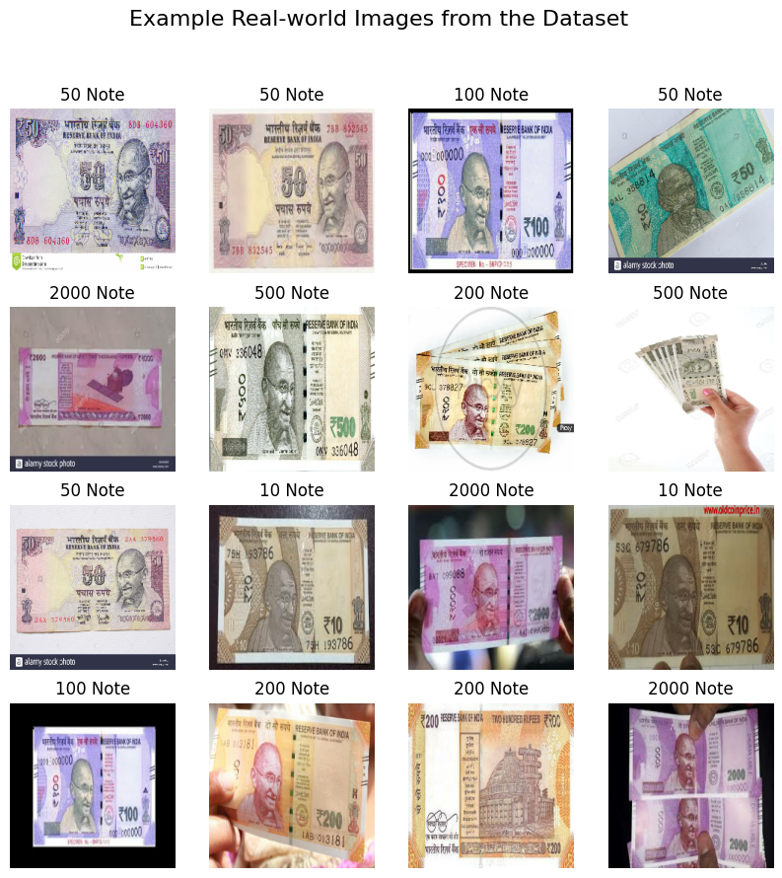

**Step 4**: Load pretrained ResNet50 model and extract features using this pretrained network. Store the extracted features and its labels in two separate list.

**Step 5**: Now train a SVM classifier over extracted features and labels.

**Step 6**: Make predictions after you fit the SVC classifier.

**Step 7**: Calculate accuracy and print confusion matrix as shown below (Values may not match but its should be logically correct, verify it by showing me).

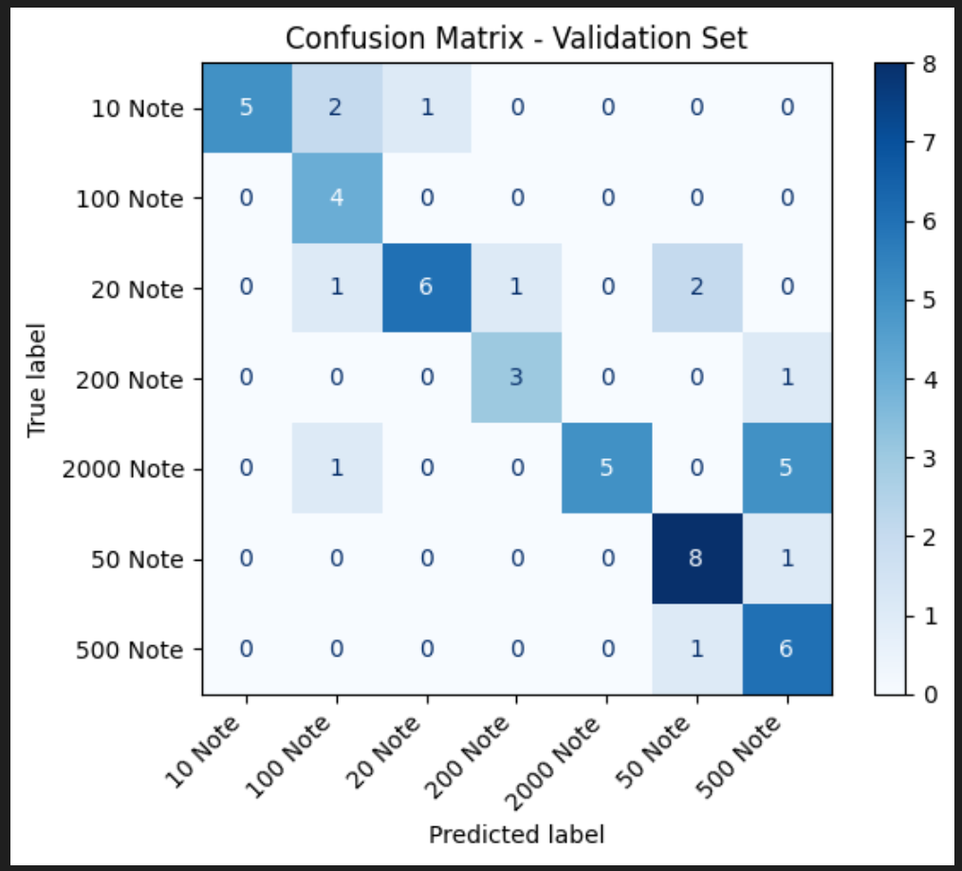

**Step 8**: Display some classified images with its labels.